**Name :** M.jeya kumar

**College code :** 9510

**College name :** infant jesus college of engineering

**Naan mudhalvan id :** au951021104004

**Project name :** data analytics with cogns

**PUBLIC HEALTH AWARENESS CAMPAIGN ANALYSIS**

Phase2_Innovation

**Problems**

It clearly states the specific problem and includes a quantitative element that describes the magnitude of the problem and its impact on society. The statement should also include a description of other efforts that are addressing the problem and definitions of relevant terms. An example of a problem statement is : A recent situation analysis of District A demonstrated limited access to young adult reproductive health services. Young adults (ages 15-24) account for 30% of the population in District A, yet reproductive health service statistics show that only 5% of the people using the services were in this age range. Anecdotal evidence from district health workers suggests a high incidence of unwanted pregnancies and a high prevalence of HIV/AIDS among young adults. As part of the national commitment to improve the reproductive health of young adults, the Ministry of Health will implement a five-year project aimed at increasing access to youth-friendly health services by improving the infrastructure necessary to deliver such services, and in partnership with the Ministry of Education and Youth, focusing on reproductive health education for youth ages 10-24.

**Solution**

## **1. Connected and cognitive devices**

Portable, wearable, ingestible, or implantable devices can monitor health and fitness information, engage patients and their communities of caregivers, and deliver self-regulated therapies autonomously.

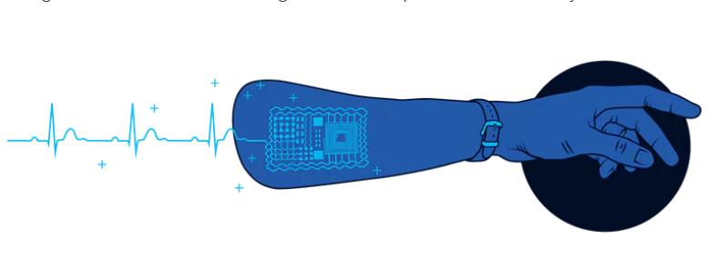

### **Example: E-tattoos for heart diagnostics**

Today’s technology relies on a Holter monitor (a battery-operated device) to monitor the heart continuously. The monitor’s batteries last for no more than 48 hours, and the procedure can cause immense discomfort for patients. Ultrathin e-tattoos can monitor hearts for longer periods and make patients more comfortable while providing a wider range of data to enhance clinical decision making.

**2.Robotics and prosthetics**

A wide variety of programmable, self-controlled devices consisting of electronic, electrical, or mechanical units and of artificial substitutes or replacements for body parts are now under development.

**Example: Next-generation exoskeletons and mobility support**

Today’s mechanical mobility aids do not fully restore movement in the elderly, so they do not prevent a loss of independence and the risk of accidental injuries. Next-generation exoskeletons, powered by small motors that mimic human muscles, could allow older patients to recover their autonomy while reducing the likelihood of accidents and falls.

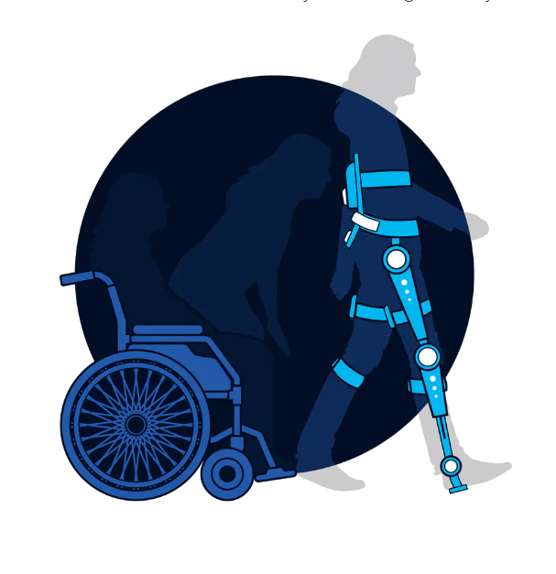

## **3. Innovative vaccines**

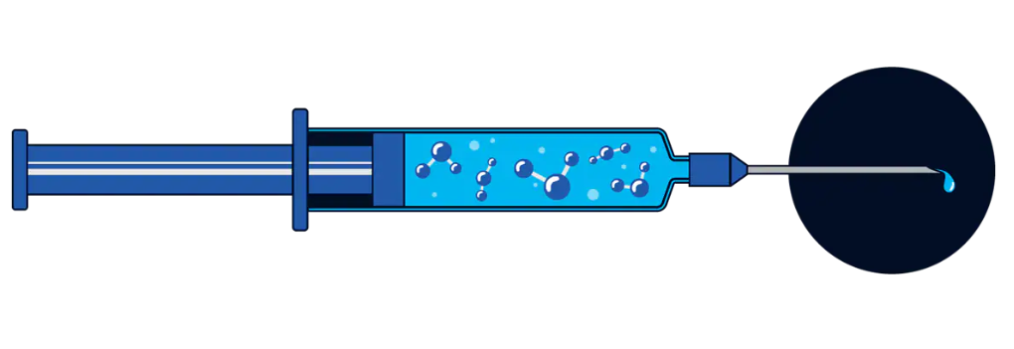 Vaccines stimulate the immune system to respond to and destroy a bacterium or virus. Historically, they have eradicated or controlled the spread of infectious diseases around the world. In the future, vaccines may target noncommunicable diseases, such as cancer.

**Example: The AT04A vaccine and the lowering of cholesterol**

At present, patients take statins (lipid-lowering medicines) to control or lower high cholesterol levels in the blood. Patients with cardiovascular disease must take these daily, but adherence is often poor. AT04A is a vaccine made up of molecules that bind to blood cholesterol and degrade it. The vaccine would be required only once a year, potentially improving outcomes.

**Flow chart**

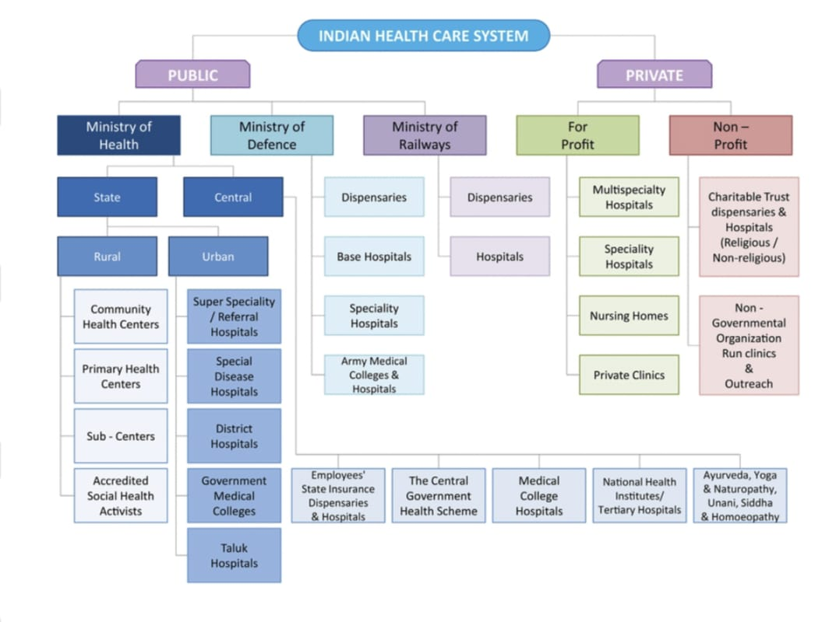

**Algorithm**

Step :1

Identify and Analyze the problem

Step :2

Try to find the solution for the problem

Step :3

Give public awareness to reduce the problem